**Daily Scrum or Standup Meeting**

Team name: Alpha Squad

Scrum Master: Alex Beeston

Date: November 4, 2019

|  |  |  |  |
| --- | --- | --- | --- |
| **Team Member** | **What did you do since the last scrum?** | **What do you plan to do before the next scrum?** | **What obstacles do you have?** |
| Alex Beeston | worked on live page so that the auctioneer can enter the name of the winning bid and the bid amount. This data is POSTed, and the next item in the queue in calculated. | Create functionality so that the next item is smoothly present, map usernames to auction number for non-bidders (like what Professor Kay said) | I had to read docs on POSTS to have any hope at getting anything done. |
| Joey Carlisle | Worked on the create item functionallity | finish the create item functionality and maybe some other stuff too | Date time is giving me issues, need to read more docs |
| Isaak Johnson | worked on filtering silent items based on bid status and displaying the current bid on an item. | make it look nice, refactor for easy readability | need create item function |
| Ben Taylor | Created the User page and got the update auction number and create user functionality working on it. | Finish the payment page. | Not sure how to get the current bid amount from each user. |

# Burndown

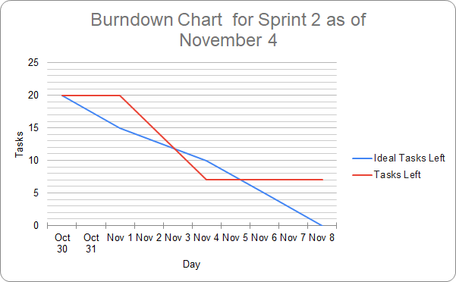

# Screenshot of you project board

